[ZANG] - [Chuanjie] - ITCAssignment

Student ID: 699382953

[chuanjiezang@gmail.com](mailto:chuanjiezang@gmail.com)

Pseudo-Code

Getting Started

Define the Vehicle class

Properties: x, y, alive

Constructor

move method

toString method

Define the Car class to inherit from Vehicle

Attributes: type

Constructor

toString method

Defines the Truck class to inherit from Vehicle.

Attributes: type

Constructor

move method

toString method

Defines the SportsCar class to inherit from Vehicle.

Attributes: type

Constructor

move method

toString method

Defines the Tractor class to inherit from Vehicle.

Attributes: type

Constructor

move method

toString method

Defines the Field class

Attributes: vertex array, vehicle array

Constructor

kill method

Defines the Simulator class

Attributes: Field

run method

Display each turn

Records vehicle movements

Define Main class

main method

Prompts for user input

Initialize the simulator

Call the simulator run method

End

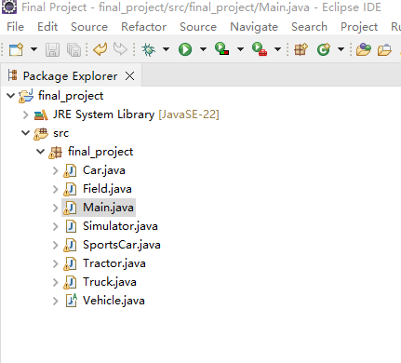

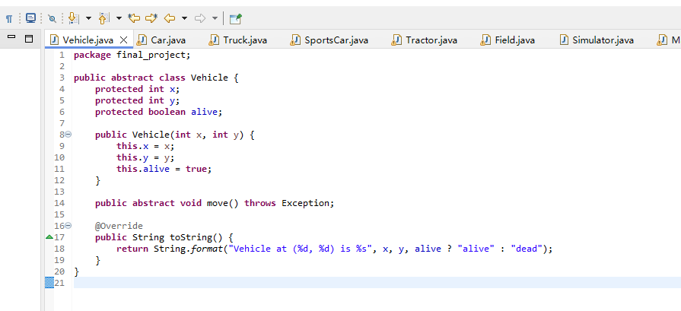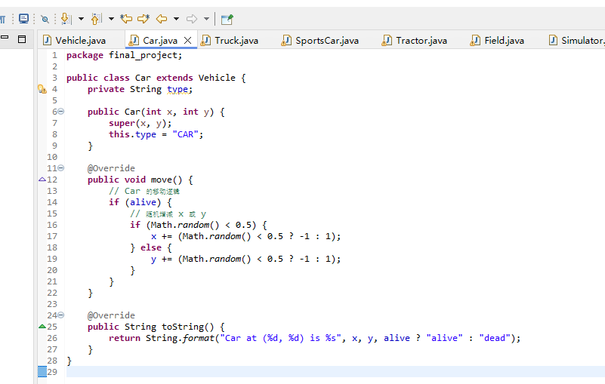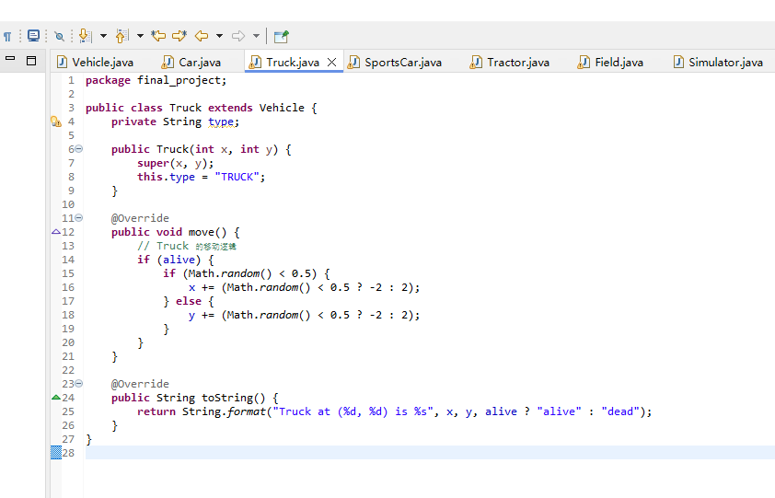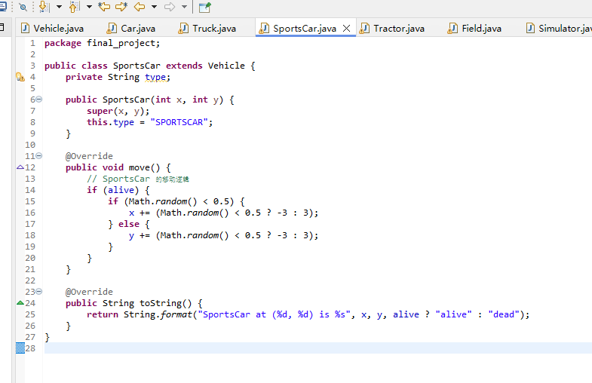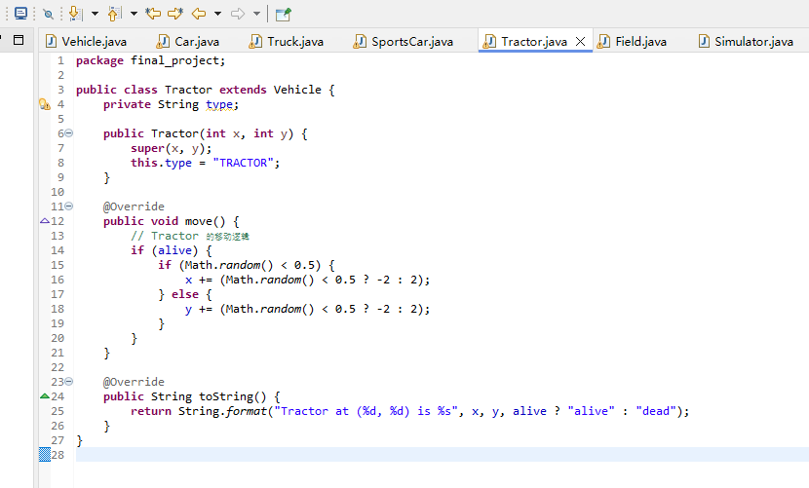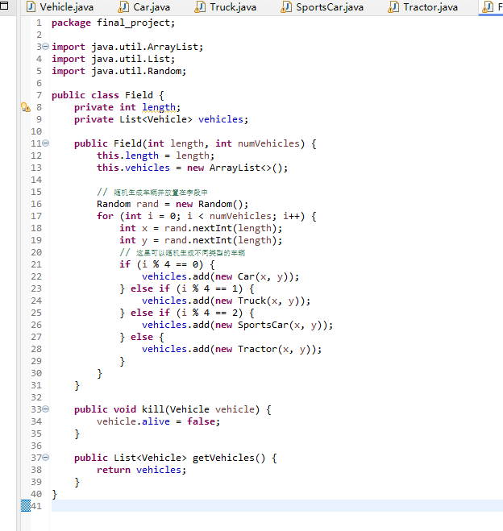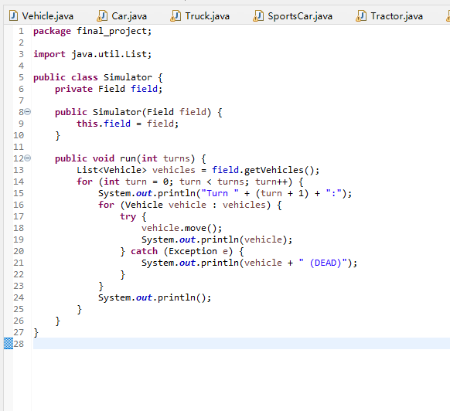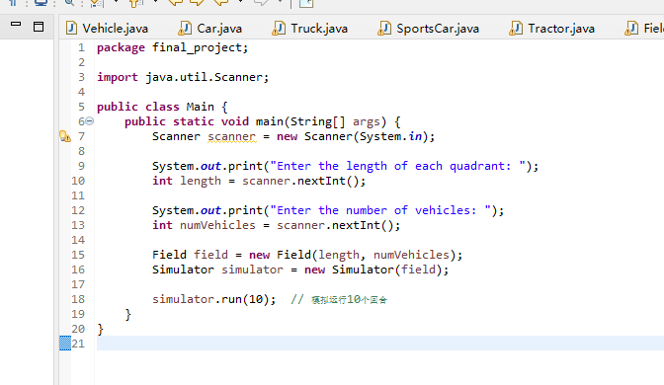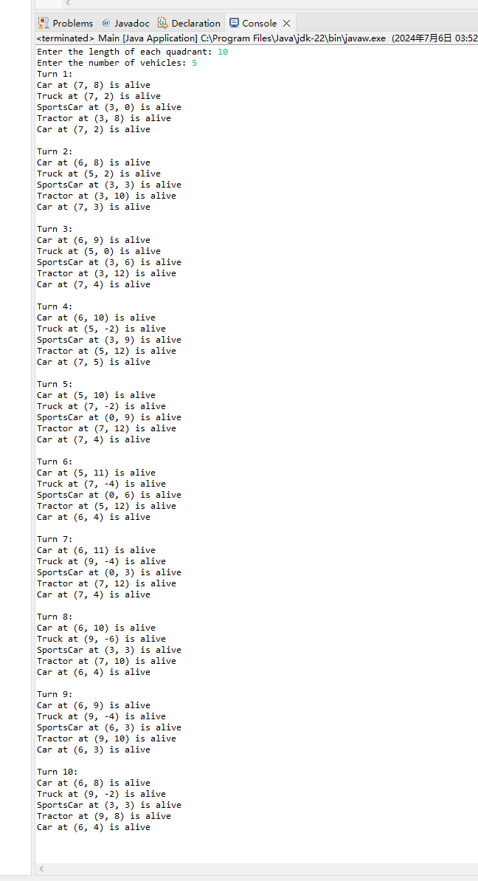

Modify the Vehicle class

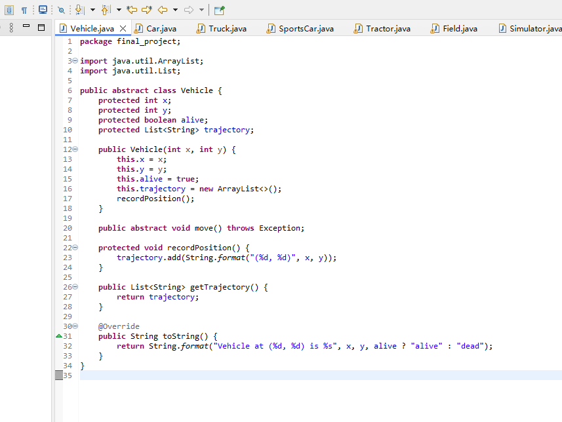

Modify the move method of the subclass Car, Truck, SportsCar, Tractor to record the position.

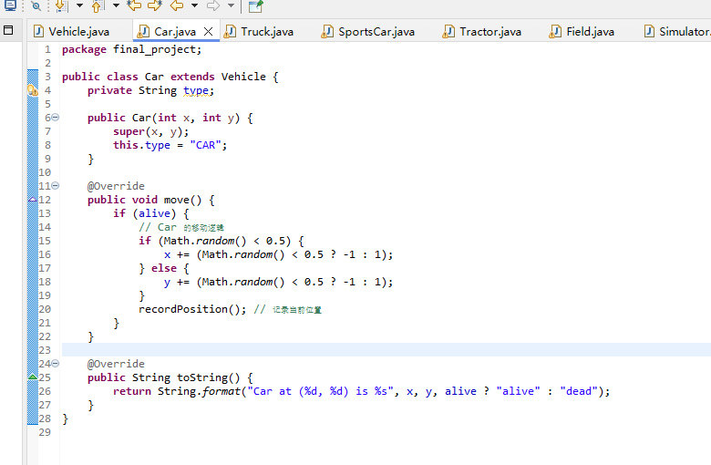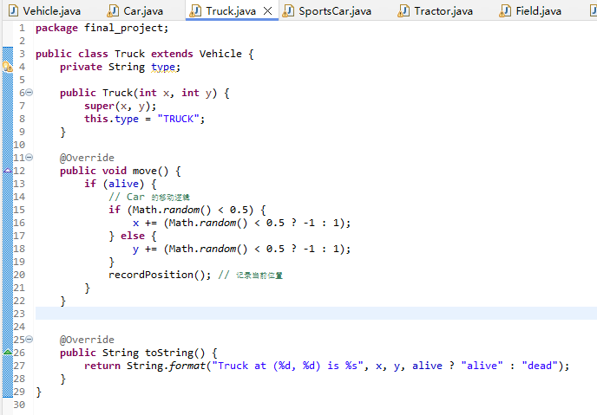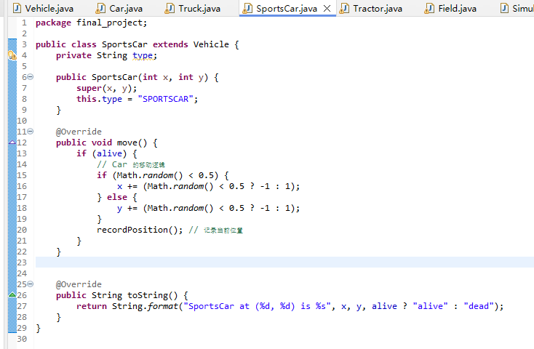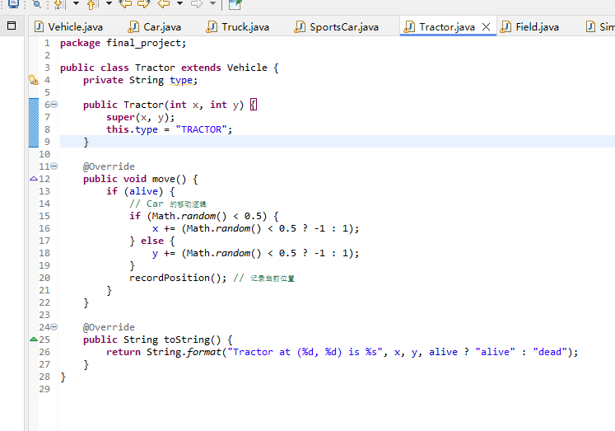

Modify the kill method in the Field class to mark a vehicle as dead when it moves out of the quadrant.

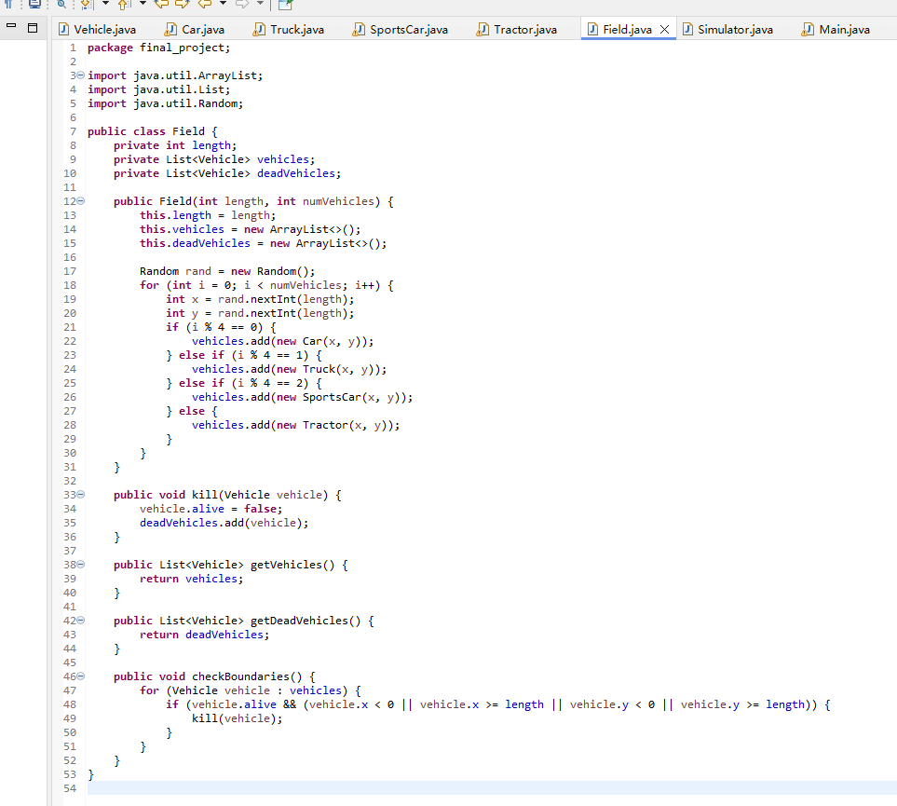

Add a method to the Simulator class to display the final result, outputting the details of the top 3 longest surviving cars.

